Project Design Phase-II
Technology Stack (Architecture & Stack)

Date | 31 January 3035
Team ID | LTVIP2026TMIDS66400
Project Name | Educational Organization Using ServiceNow
Maximum Marks | 4 Marks

Technical Architecture:
The Deliverable shall include the architectural diagram as below and the information as per the table1 & table 2
Example: Order processing during pandemics for offline mode
Reference: https://developer.ibm.com/patterns/ai-powered-backend-system-for-order-processing-during-pandemics/
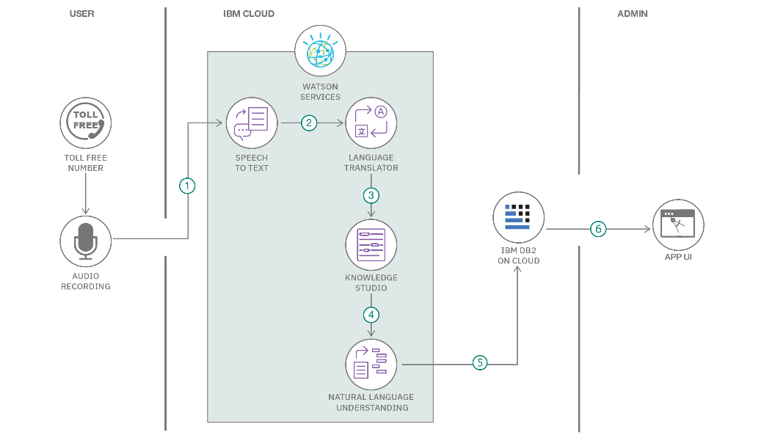

Table-1 : Components & Technologies:
S.No | Component | Description | Technology
 | User Interface | How user interacts with application e.g.  Web UI, Mobile App, Chatbot etc. | HTML, CSS, JavaScript / Angular Js / React Js etc.
 | Application Logic-1 | Logic for a process in the application | Java / Python
 | Application Logic-2 | Logic for a process in the application | IBM Watson STT service
 | Application Logic-3 | Logic for a process in the application | IBM Watson Assistant
 | Database | Data Type, Configurations etc. | MySQL, NoSQL, etc.
 | Cloud Database | Database Service on Cloud | IBM DB2, IBM Cloudant etc.
 | File Storage | File storage requirements | IBM Block Storage or Other Storage Service or Local Filesystem
 | External API-1 | Purpose of External API used in the application | IBM Weather API, etc.
 | External API-2 | Purpose of External API used in the application | Aadhar API, etc.
 | Machine Learning Model | Purpose of Machine Learning Model | Object Recognition Model, etc.
 | Infrastructure (Server / Cloud) | Application Deployment on Local System / Cloud  Local Server Configuration:  Cloud Server Configuration : | Local, Cloud Foundry, Kubernetes, etc.

Table-2: Application Characteristics:
S.No | Characteristics | Description | Technology
 | Open-Source Frameworks | List the open-source frameworks used | Technology of Opensource framework
 | Security Implementations | List all the security / access controls implemented, use of firewalls etc. | e.g. SHA-256, Encryptions, IAM Controls, OWASP etc.
 | Scalable Architecture | Justify the scalability of architecture (3 – tier, Micro-services) | Technology used
 | Availability | Justify the availability of application (e.g. use of load balancers, distributed servers etc.) | Technology used
 | Performance | Design consideration for the performance of the application (number of requests per sec, use of Cache, use of CDN’s) etc. | Technology used

Technical Architecture:
This project uses a low-code architecture powered by ServiceNow PDI (Personal Developer Instance). It includes:
Creation of custom tables for student admissions and academic progress,
Client-side automation via scripts,
Use of default ServiceNow components for workflows, forms, and UI.
The architecture is cloud-hosted, scalable, secure, and ideal for rapid educational workflow deployments.
Table-1 : Components & Technologies:
S.No Component Description Technology
1. User Interface Web UI where admin interacts with forms ServiceNow Form UI, HTML/CSS
2. Application Logic-1 Business logic for student admission process Client Scripts in JavaScript
3. Application Logic-2 Auto-fill, validations, dynamic updates GlideForm (g_form) APIs, JS
4. Application Logic-3 Result calculations and conditional logic Client Scripts
5. Database Stores student, admission, and academic records. ServiceNow Tables (MySQL-based)
6. Cloud Database Cloud-hosted internal DB through ServiceNow instance Hosted on ServiceNow Cloud DB
7. File Storage File uploads or documentation if added in future Not implemented (can extend)
8. External API-1 Optional for integrating school data from third parties (Future scope)
9. External API-2 Optional for Aadhaar/OTP-based student verification (Future scope)
10. Machine Learning Model Not applicable for current version NA
11. Infrastructure (Server / Cloud) Cloud-hosted PDI provided by ServiceNow ServiceNow Cloud Infrastructure
Table-2: Application Characteristics:
S.No Characteristics Description Technology
1. Open-Source Frameworks Client-side scripts and Glide APIs used in ServiceNow environment JavaScript (within ServiceNow)
2. Security Implementations Role-based access, record security, ACLs, and default ServiceNow IAM policies RBAC, ServiceNow Security Model
3. Scalable Architecture Tables and modules can be extended; ServiceNow handles horizontal scaling ServiceNow’s scalable cloud infra
4. Availability Highly available via ServiceNow PDI (99.9% uptime), accessible through browser ServiceNow Cloud
5. Performance Optimized with server-side processing and client scripts; designed for minimal latency ServiceNow backend engine, caching mechanisms

References:
https://c4model.com/
https://developer.ibm.com/patterns/online-order-processing-system-during-pandemic/
https://www.ibm.com/cloud/architecture
https://aws.amazon.com/architecture
https://medium.com/the-internal-startup/how-to-draw-useful-technical-architecture-diagrams-2d20c9fda90d

